**Researching Games with Similar Mechanics**

To assist with my development of ideas for level and character design, researching other games that use similar mechanics is imperative for finding out what will work and what won’t.

*“Speedrunners”* is a multiplayer competitive game in which groups of 4 players compete in an elimination race around a looping level. If they end up off-screen by being too far behind, they lose a life. Whoever is left gets a point, and once they reach a certain amount of points they win the game.

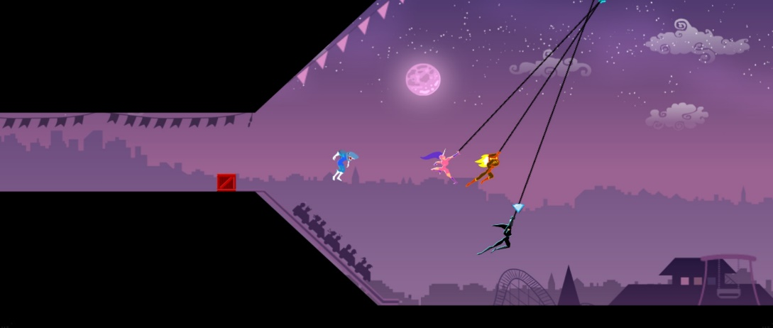While there are items and special moves, what I want to focus on is the grappling hook mechanic, as this is a major focus for our product. This game has both jumping and the grappling hook, as the grappling hook is used as both a tool for helping cross gaps that the jump is not large enough for, but also rewards skilled players who can hit moving targets-the other players-and use them to get ahead of the competition.

Figure : A gameplay screenshot of "Speedrunners" showing the grappling hook in action.

While our product will not have a jump at all, this is still a useful game to analyse due to the way the grappling hook is multi-purposed; the grappling hook in our game could follow suit and not just be used for crossing gaps or getting over obstacles, but potentially as a form of combat to subdue enemies and potentially solve puzzles.

“*The Legend of Zelda*”, a series of high-fantasy action games, has its own form of the grappling hook throughout most of the games that is used to solve puzzles. In these games it is usually referred to as the “hookshot” (though this is just semantics as it functions exactly the same as a grappling hook), and in the *Zelda* game “*Ocarina of Time”* specifically, the hookshot is used for a variety of purposes.

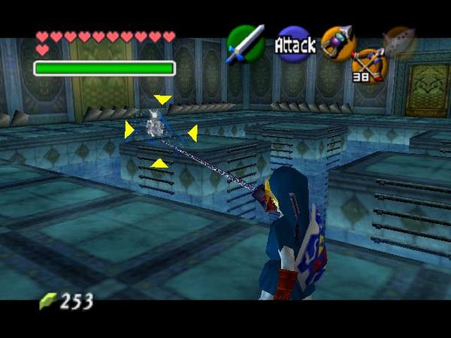Due to the context-sensitive nature of the action buttons in *Ocarina of Time*, the hookshot’s uses vary depending on what’s being targeted. Some enemies and bosses are “puzzle bosses” that can only be made vulnerable to attack by using the hookshot-such as the boss in Figure 2-and certain items in far away places can only be reached by using it. Additionally, there are certain buildings that the player can climb to surpass roadblocks in the game (due to the lack of jumping outside of specific areas), so the player is rewarded for using all the tools they have collected thus far to problem solve.

Figure : The hookshot being used to expose a boss' weakness

*“Super Metroid”* and “*Super Castlevania IV”* (abbreviated to *SC4* from now on for the sake of brevity) are 2D games-exploration and action-respectively that uses a “grappling” weapon in different ways.

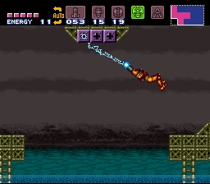As figure 3 shows, *Super Metroid* has the “grapple beam” which aids exploration by allowing the player to swing off of certain blocks to cross gaps that would be impossible to cross otherwise. These blocks that can be grappled off of stand out deliberately to act as a non-verbal communicator for the player, as they will remember these blocks standing out and once they get the grapple beam (in a room that can only be exited by using these blocks) they will instinctively travel back to this area to cross it. The level design in this game is a perfect example of “show, don’t tell” and is definitely a good source of inspiration due to how interconnected all the areas are.

Figure 3: The grapple beam in action

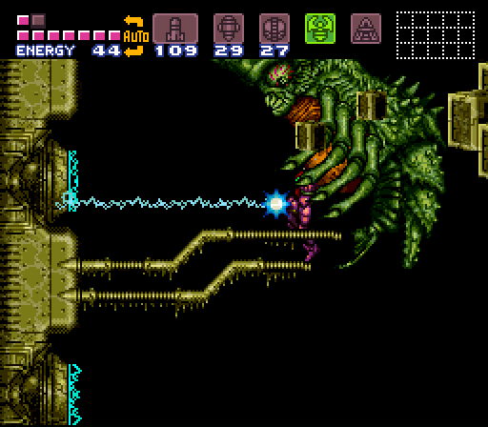Figure 4 demonstrates that the grapple beam is also used to reward particularly attentive players. One of the boss fights in the game takes place underwater, and the boss has a particularly dangerous attack where they grab the player and rapidly drain their health. If the player destroys a node on the side of the arena, it reveals an electric current that looks exactly like the grapple beam. If they deliberately get themselves grabbed, and then shoot the grapple beam at this electricity, the boss is electrocuted and instantly defeated. This level of detail is yet another layer of design that I will need to consider when designing the levels for our project.

Figure 4: The grapple beam being used to instantly defeat a boss

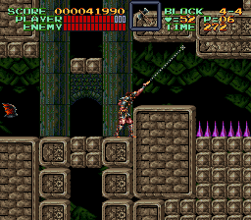In *SC4*, the grappling hook is actually a whip. This whip is multipurpose, as it can be used to cross gaps by swinging off of certain objects but is also the player’s primary means of defeating enemies. The whip is omnidirectional, which gives the player a lot of freedom to attack enemies, but the whip also has a unique property; it can be freely swung about to block incoming projectiles and hit enemies very quickly to kill them much faster. This move gives the player even more freedom to tackle obstacles, especially when there are multiple enemies on screen.

In conclusion, these games all use grappling hooks for both conventional and unique purposes; and provide further insight into how long-range weapons can be utilised in a character’s arsenal to allow the player to traverse levels and defeat enemies in more ways than just running right and jumping. They also provide questions for me to answer when designing the levels and playable character: how much mastery will they have over their grappling hook? How can I make areas of levels memorable so that the player knows to return there once they’ve progressed further in other areas? How will I design enemies to coerce the player into using all their abilities to get past them? These are all things that must be taken into consideration.